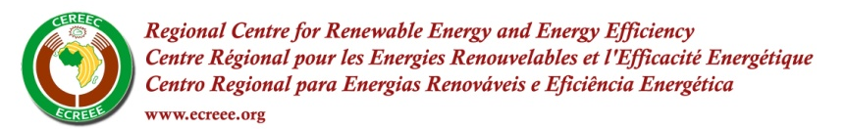
PRESS RELEASE
For immediate release, 1st October 2012
ECOWAS Renewable Energy Investment and Business Initiative
1st Edition of the RE Investment and Business Forum
27th and 28th of September 2012, Dakar, Senegal

Dakar, Senegal – ECREEE and the African Development Bank (AfDB) organize the first ECOWAS Renewable Energy Investment and Business Forum held on the 27th and 28th of September in Dakar The Forum was attended by over 90 participants from the ECOWAS member states, Europe and USA. Participants at the forum were mainly financiers, project promoters, donors and market analysts interested in the investment opportunities in renewable energy power plants in the ECOWAS Region.
This forum was the first milestone of ECOWAS Renewable Energy Investment and Business Initiative (EREI) establish by ECREEE. The Forum was part of an effort to fulfill ECREEE’s mandate to attract investments on Renewable Energies (RE) as laid out in the ECOWAS White Paper geared towards improving access to energy services for the rural and peri-urban populations in West Africa. Periodically; investors, financiers and promoters of RE projects in West Africa will meet under the umbrella of ECOWAS governments, through its specialized agency (ECREEE).
The Forum presented a pipeline of 40 renewable energy projects in the ECOWAS region, consisting of various RE technologies (photovoltaic, wind, small hydro and biomass), with an overall expected capacity of 552 MW, estimated at approximately 1.5 billion EURO. The Forum acted as a communication bridge between promoters of RE projects and financial partners in the ECOWAS Region who expressed great interest and importance in the projects presented by ECREEE and the advocacy of a new paradigm in the energy sector, taking into account the renewable energy technologies.
The forum outcome proved successful as all the parties agreed about the timeliness and the focus of the forum on investment in the renewable energy sector. 2013 has been earmarked for the second edition of the forum and some financiers have already showed their interest to support it.
About ECREEE: The ECOWAS Regional Centre for Renewable Energy and Energy Efficiency (ECREEE) was established by the ECOWAS Council of Ministers. ECREEE commenced operation in 2010 with initial support of the Austrian and Spanish Governments and technical assistance of the United National Industrial Development Organization (UNIDO). The ECREEE Secretariat is based in Praia, Cape Verde, and maintains a network of National Focal Institutions (NFIs) located in all ECOWAS member countries. ECREEE aims to improve access to modern, reliable and affordable energy services, energy security and reduction of energy related GHG emissions and climate change impacts on the region’s energy system. ECREEE’s specific objective is therefore to create favourable framework conditions and an enabling environment for renewable energy and energy efficiency markets by supporting activities directed to mitigate existing barriers. These activities include policy development, capacity building, awareness raising, knowledge management as well as business and investment promotion.

For additional information on the workshop, please contact the ECREEE Secretariat at investment@ecreee.org.

